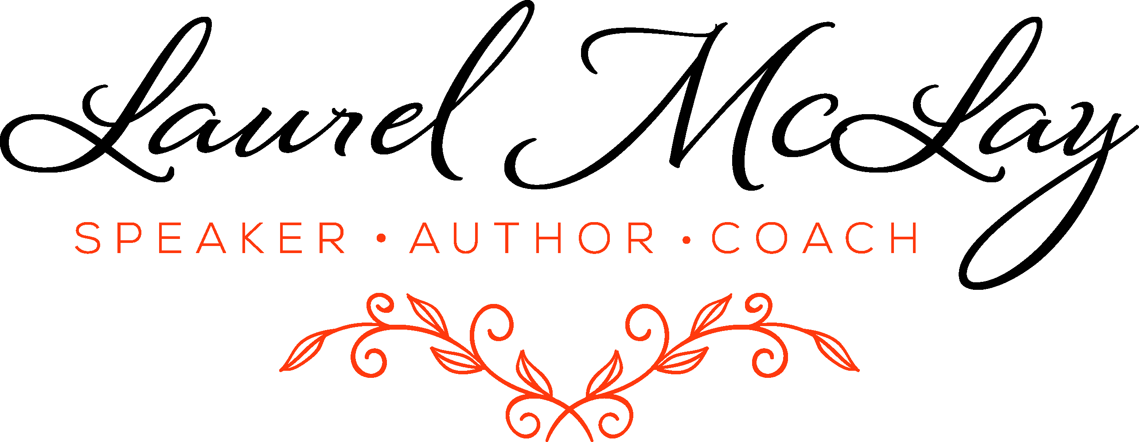
Tolerations Matrix
One of the ways we can work out how to design a career, business or lifestyle that works for us, is to work out what we actually don’t want in our lives! A very powerful way to explore the latter is to look at what we are tolerating. So often we are on auto pilot, and simply exist (or even just survive) in some parts of our lives. It is not until we get clear on what exactly we are tolerating that we start to understand those patterns. The great thing is, like so many things, once we see it written down in front of us, we are a good way down the track.
This is an extraordinarily powerful exercise for you to complete, in your own time, ensuring you have no distractions. It is particularly impactful when it is done outside of your everyday environment, eg on holiday, or even in a nice outdoor spot on your own. It shouldn’t take long, and the best way to answer it is intuitively. Just answer each question out of 100% based on how you feel about that area right now, eg you might feel 80% about your relationship with your significant other and 20% about your ability to sleep. It is also a good idea not to be too dramatic about this exercise, treat it lightly and without going into any drama. If the question relates to a part of your life that is particularly causing you stress or worry right now, please highlight that in the notes column.
And definitely don’t use this as an excuse to criticise/beat yourself up, or come from massive judgement around any of these areas. It’s by shining the light on our wobbly bits that we see the real us, and by welcoming all of us, we can live richer fuller more prosperous lives. Denial is a dangerous beast!
So, what are the areas that you are going to look at in this matrix?
There are generally five key areas of our life that define our happiness;

- Wellbeing
- Finance and abundance
- Relationships and community
- Career and purpose
- Support structures
The key areas within each have been identified, but please feel free to add any other areas not highlighted that are relevant to you. If they don’t apply, just insert N/A (eg you are not presently in a relationship or don’t own a business).
What happens next, is that you can look for outliers; those things that are rated above 80% and those that are rated below 50%. Celebrate the high rating areas (it’s not something we do enough of!) and create a plan to address the lower rating areas.

1. Support Structures
Area | % | NOTES
My time management (including diary management and ability to turn up to appointments on time – including personal/social)
The clutter in my life (general) – including that drawer that most of us have and wardrobe
My workspace environment
The state of my home
The state of my car
My goals (I like to call them intentions) identified, written and tracked regularly (eg monthly, quarterly, yearly)
My task management and to do list (eg Nozbe, Asana, Outlook, good hard copy diary)
A mechanism for capturing cool stuff (eg ideas that come out of my head, or interesting stuff that I read) in a journal or app
The way my business is supported, eg a great team of people who I can rely on (if applicable)
My use of other structures for personal use (eg computer applications like OurGroceries, diary, systems)
Processes and systems for my business (if applicable)
Friends/family members who support me in general
Friends/family members who I know will support me in times of crisis
Mentors, coaches, healers
Other (please identify)

2. Finance and Abundance
Area | % | NOTES
My general relationship with/thoughts about money (eg abundance/scarcity or trusting that ‘the money will come’ when I am in a financial pickle)
What I currently earn
What my future earnings look like (regardless of whether that involves changing from what I am doing now or not)
How I am fulfilling on any revenue generation responsibilities (eg for my own business, for my employer, for myself)
My revenue generation strategy (if specifically responsible)
My pipeline size and quality (if responsible for one)
My ability to spend money on myself
My ability to spend money on others/my level of generosity
My ability to save/invest
My ability to ‘hold on’ to money, ie how quickly it disappears when I receive it and/or lack of impulsiveness around spending it
My liquidity/access to cash
My balance sheet (ie my assets minus my debts)
My retirement fund
My general sense of security (eg rainy day fund, income protection insurance, life insurance re dependents)
The amount of time I spend thinking about/worrying about money (ie 100% would mean you never worry about it)
Other (please identify)

3. Career, Purpose and Fulfilment
Area | % | NOTES
My life purpose – knowing it, feeling like I have clarity on what it is I am truly meant to be doing
My life purpose – living it, ie knowing that what I am doing now is what I am truly meant to be doing
My sense of contribution – paid – ie how much of a difference I feel that I am making because of the work that I do
My sense of contribution – unpaid - ie how much of a difference I feel that I am making through charity work and how much I support my friends/family/communities
My freedom and flexibility, eg being able to manage my career with other parts of my life (eg ability to take time off for a family event, the number of hours I need to vs choose to work)
My downtime; how much time I get to do nothing, or my own projects in a normal week
My ability to have holidays/take time off when I choose
Working with people who I love spending time with, who energise me (vs drain me) – including co-workers, clients, bosses and suppliers
Being paid what I am worth
The ease/flow with which I work – ie how often does time ‘disappear’ when I am working
My hobbies/special interests/creative pursuits that I embrace that are not revenue generating
The sense of fun in my life
Other (please identify)
4. Wellbeing
Area | % | NOTES
My energy levels
My fitness level
My ability to sleep
My eating habits, eg how much I feel that what I eat on a given day or week fuels me; the amount of living/good food that I eat vs high fat/salt/sugar/junk food
How much water I drink daily
Freedom from possible dependencies eg tobacco, caffeine, energy drinks, alcohol, drugs (prescribed or recreational), gambling, shopping, adrenalin, gaming, sugar, work, device (phone or tablet) time, TV time (including reality TV)
My relationship with food, eg emotional or binge eating, cravings, ability to control how much of that chocolate bar in the fridge I will eat in one sitting, or how many nibbles I will consume in a social setting
My weight
My tone/body shape
My general health (eg absence of sickness)
Freedom from specific anxieties or phobias, eg fear of flying, public speaking, injections, spiders, death, Obsessive Compulsive Disorder
Freedom from anxiety, stress and worry in general
My ability to surrender, give up control and simply allow a situation to play out (able to be in the present moment/sense of flow, my faith)
Meditation/prayer or other quiet time ritual
Other (please identify)

5. Relationship* and Community
Area | % | NOTES
With my significant other (including intimacy and trust)
With my mum (and/or stepmum)
With my dad (and/or stepdad)
With my siblings (and or stepsiblings)
With my child/ren (and/or stepchildren)
With extended family members (my own)
With extended family members (my partner’s), if applicable
With my extended step-family (if applicable)
With close friends
With my community/ies – eg neighbourhood, school, special interest
My level of socialising in general
My level of entertaining in general
My clients (if applicable)
My suppliers (if applicable)
My team (if applicable)
Other business/special interest colleagues and influencers
Other (please identify)
*feel free to complete this for any family members who have passed away
Thanks for completing this. Highlight the areas in each part of your life that you have rated the least score. These are a great place to start when you are looking at how you would ultimately love to be living your life.

